**DEVELOPER GUIDE**

This Is A Developer Guide for The Website of Universal Stationery Which Was Made by The Students of Aptech For the Purpose Of

E-Project.



**GROUP MEMBERS**

“Syed Muhammad Danish, Student: 1340587”

“Muhammad Hamza Sohail, Student: 1340542”

“Muhammad Ahsan, Student: 1343003”

**FACULTY :** AATIKA LIAQUAT

**BATCH CODE : 2110C1**

**CURRICULUM : 6672**

**HOME PAGE**

**In start you will see a Logo & header Image, then index page shows the Top Categories of the site, then index page shows the Exclusive of the site, then index page shows the Best Sellers & Brand Logos of the site, Then index page shows the Contact Address & Footer of the site at the bottom,**

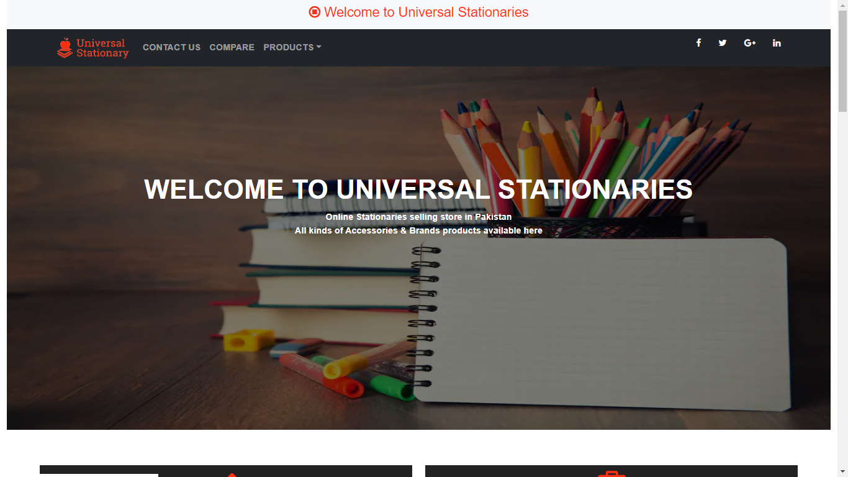

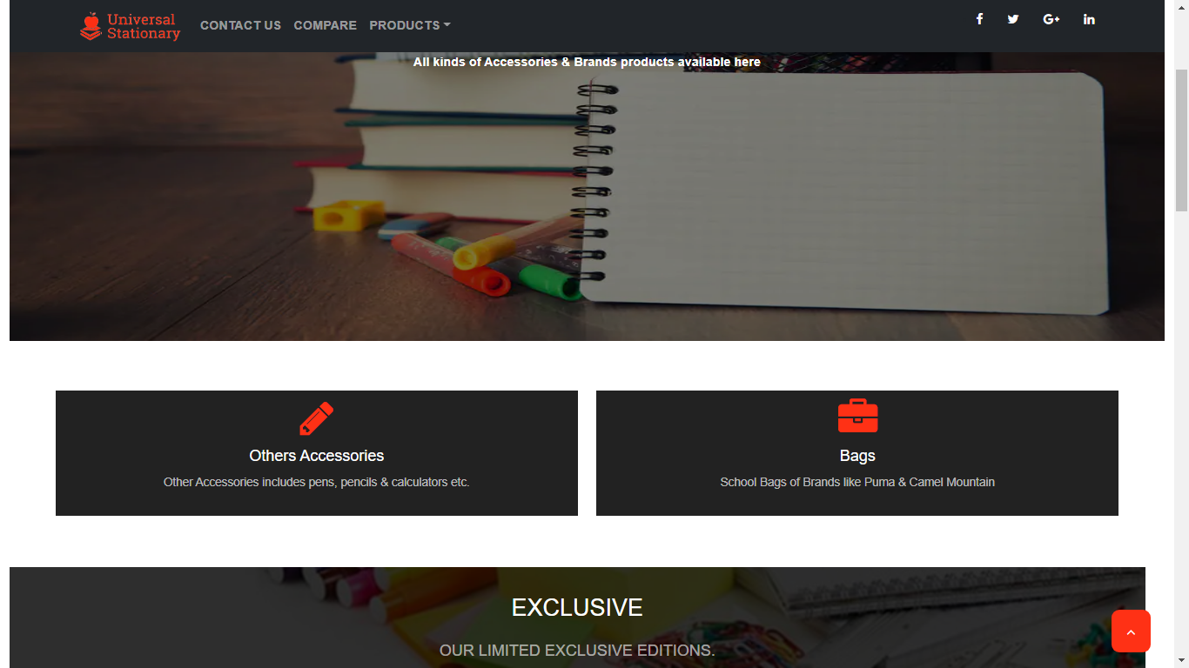



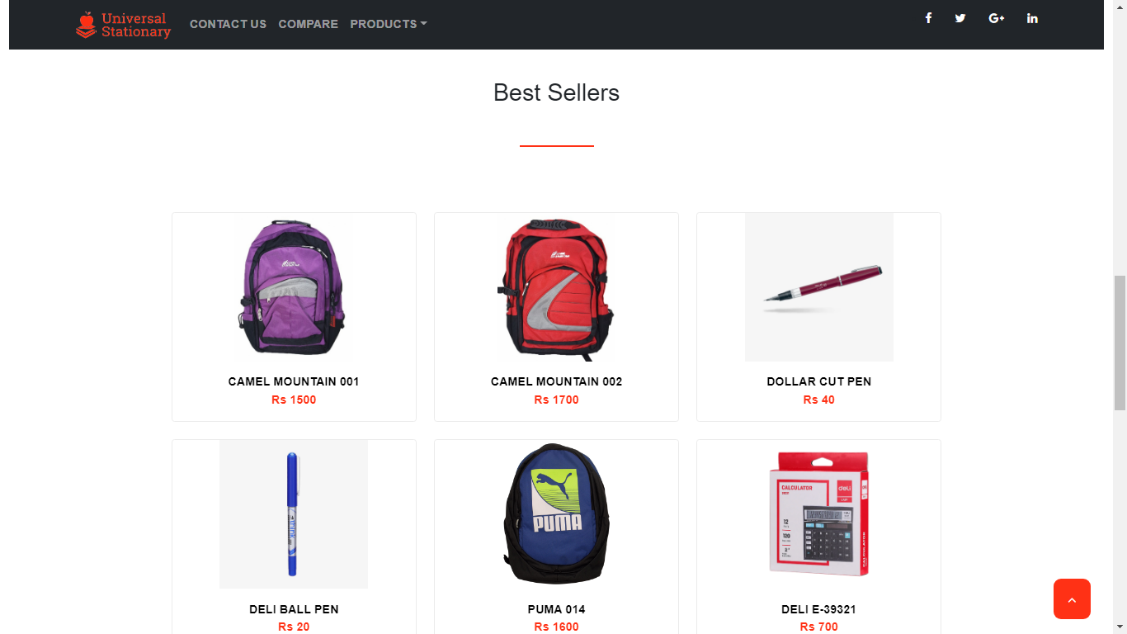

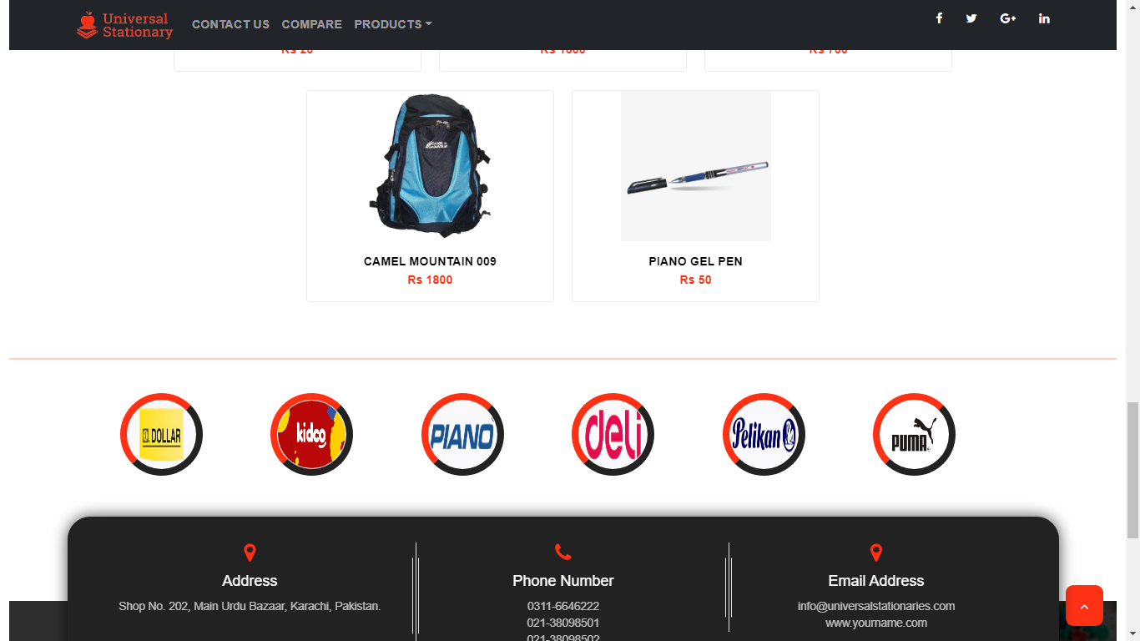

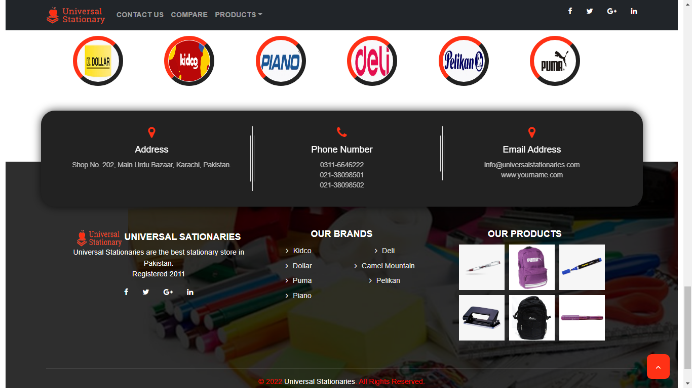

**CODE:**

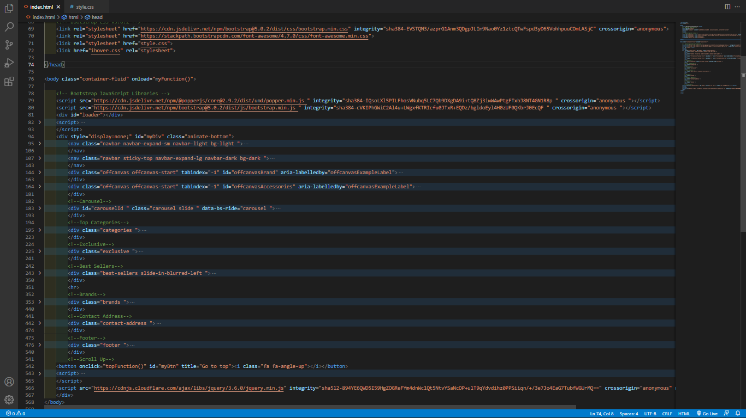

**Then shows Contact Page, There Is Location Marked on The Map and Our Contact Us Details**

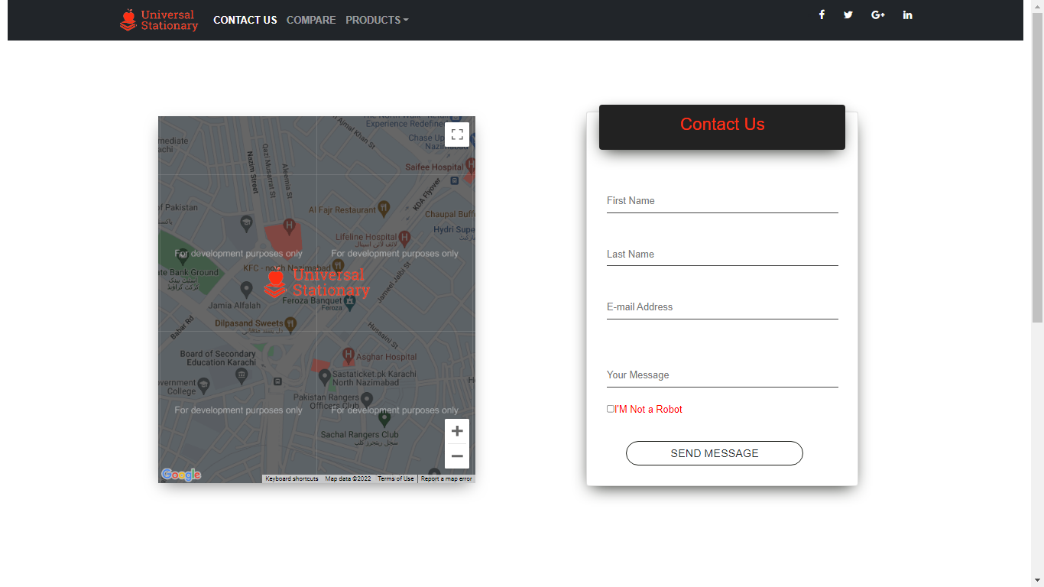

**CODE:**

**Contact Page Map API Scripting;**

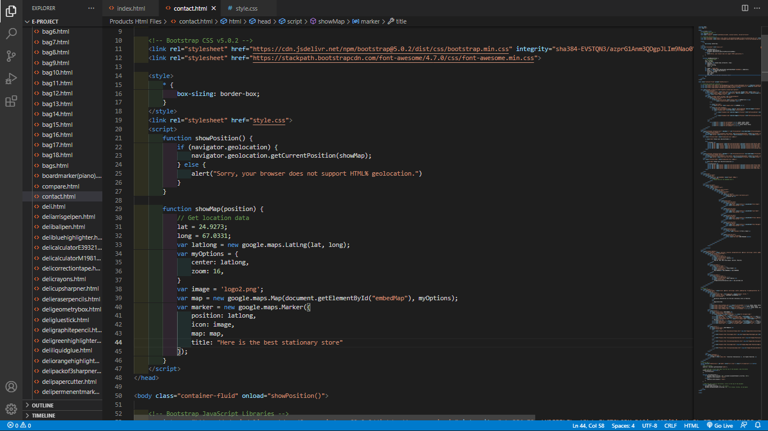

**Then shows Compare Page, the is product to product comparison.**

**Contact Page Map API Scripting;**

**Code:**



